CRUISE PLAN R/V WECOMA

Oregon State University, College of Oceanic & Atmospheric Sciences

FILING DATE: | 3/16/2010
CRUISE NUMBER: | W1004A
TITLE: | CMOP mooring cruise
CONTRACT/GRANT NUMBER: | U0440B
PRINCIPAL INVESTIGATOR(S): | Murray Levine / Antonio Baptista

PURPOSE: (Short, non-technical statement on how cruise relates to overall project)
Recover existing moorings (2) and redeploy moorings (2) at NH-10.
Deploy moorings on the shelf at sites 3mi and 16 mi from the Columbia River.
Recover and deploy glider on the shelf near the Columbia River.
CTD stations on the shelf and in the estuary at slack tide.

ITINERARY: (Include station positions and route waypoints.
Sunrise: 0630; Sunset: 2000 PDT
Perfect weather scenario…

Wed Apr 14 -- load ship

Thu Apr 15 –
1000 Transit to last known site of buoy Sitka, 3.6 nm north of NH-10 (44° 42.0’N, 124° 17.0’W)
1300 Recover Sitka
1500 Release ADP (44° 38.42’N, 124° 18.25’W), Deploy ADP at NH-10, recover anchor
1800 Deploy Alder at NH-10
2000 CTD casts at NH-10 and nearby, if there is time
2300 Transit to OGI02 (46° 2.13N, 124° 14.63W), 16 nm off Columbia River

Fri Apr 16 –
0800 On station at OGI02 for mooring deployment (300’wire, 300’ chain); surface buoy, no instruments on chain, anchor 1500# (can be dropped or lowered).
1000 Transit to SATURN02
1200 On station for mooring deployment (150’ wire, 150’ chain); surface buoy, instruments on 75’ of wire pre-attached and lowered gently into water. Anchor 1500# (prefer lowered).
1400 Transit to glider pick-up site (TBD)
1600 Launch RHIB and recover glider
1800 Night Ops (TBD, maybe some plume CTDs; ADCP survey)

Sat Apr 17 –
Early morning- Cross bar. Ability to do estuary CTD stations will depend on tide and ship traffic; some adjustments may be necessary. Ideally the 6 stations would be:
South Channel (center around slack water at 1252):
46° 11.5’N, 123° 54.6’W
46° 11.9’N, 123° 48.6’W
46° 13.3’N, 123° 42.9’W
North Channel: (center around slack water at 1701)
46° 14.3’N, 123° 56.2’W
46° 13.8’N, 123° 52.4’W
46° 14.6’N, 123° 47.9’W

1800 Leave estuary before dark
2100 Night Ops (TBD, maybe some plume CTDs; ADCP survey)

Sun Apr 18 –
0800 On station to deploy glider on shelf north of Columbia (location TBD); RHIB not needed to deploy, but may be needed in emergency.
1000 Transit to deep water site (TBD) for calibration CTD cast on the way back to Newport.
Arrive Newport late evening, if all goes well.

WILL RADIOACTIVE METHODS BE USED? | NO

SAMPLING PLAN:
See itinerary above

EQUIPMENT REQUIRED: (Should be included on Shared-Use Equipment request form)
CTD with Chlorophyl fluorometer, transmissometer, DO
Flow-through DAS system
Gifford wide mouth mooring block (with load cell if possible, in center of A-frame) for mooring work.
Crane (buoy deployment/recovery, moving anchors at sea, loading/unloading).
Trawl winch with 3/8” working wire to be “over-wrapped” with mooring during recovery, and wide mouth level wind.
Capstan and deck turning block, hydraulic tugger winch on A-frame (starboard side), ½” long link vertical “stopper” chain on starboard side of A-frame, compressed air for pneumatic tools on deck.

SCIENTIFIC PERSONNEL TO BE ONBOARD: (Provide full legal name & affiliation)
Scientist in Charge: | Murray Levine (OSU)
Co-Chief Scientist(s):
Party Chief:
Technicians: | Walt Waldorf (OSU), Michael Wilkin, Katie Rathmell, Greta Klungness, Victoria Campbell, Charles Seaton, Jeff Schilling (OHSU)
Grad Students: | Peter Kahn, Michelle Maier (OHSU)
Undergraduate Students:
Observers:

OSU Marine Technician(s) Assigned to Cruise: | Daryl Swensen, David Langner

USER SUPPLIED EQUIPMENT:
Estimated Weight:
Location:

OTHER BULKY HEAVY ITEMS:
Surface buoy “Sitka” (1000#) and anchor (2500#)
Subsurface buoy ADP (500#) and anchor (800#)
Surface buoy “OGI 02” (1000#) (USCG yellow 2CFR) and anchor (1500#)
Surface buoy “SATURN 02” (800#) (see attached picture) and anchor (1500#)

BILLING INFORMATION:
Name: | COAS
Address:
City, State, Zip
Phone:
Account Number (or number to reference):

DO YOU WANT CELLULAR/INMARSAT PHONE ACCESS: | NO
(Chief Scientist will be responsible for all charges – dedicated science phone.)

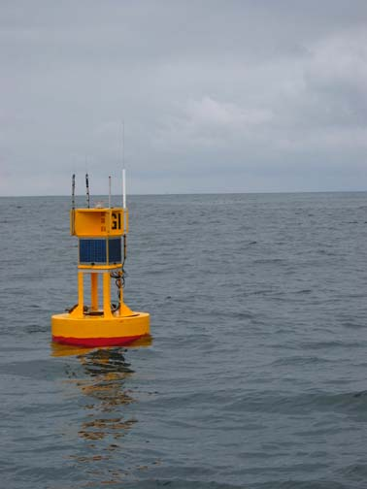

SATURN 02 buoy

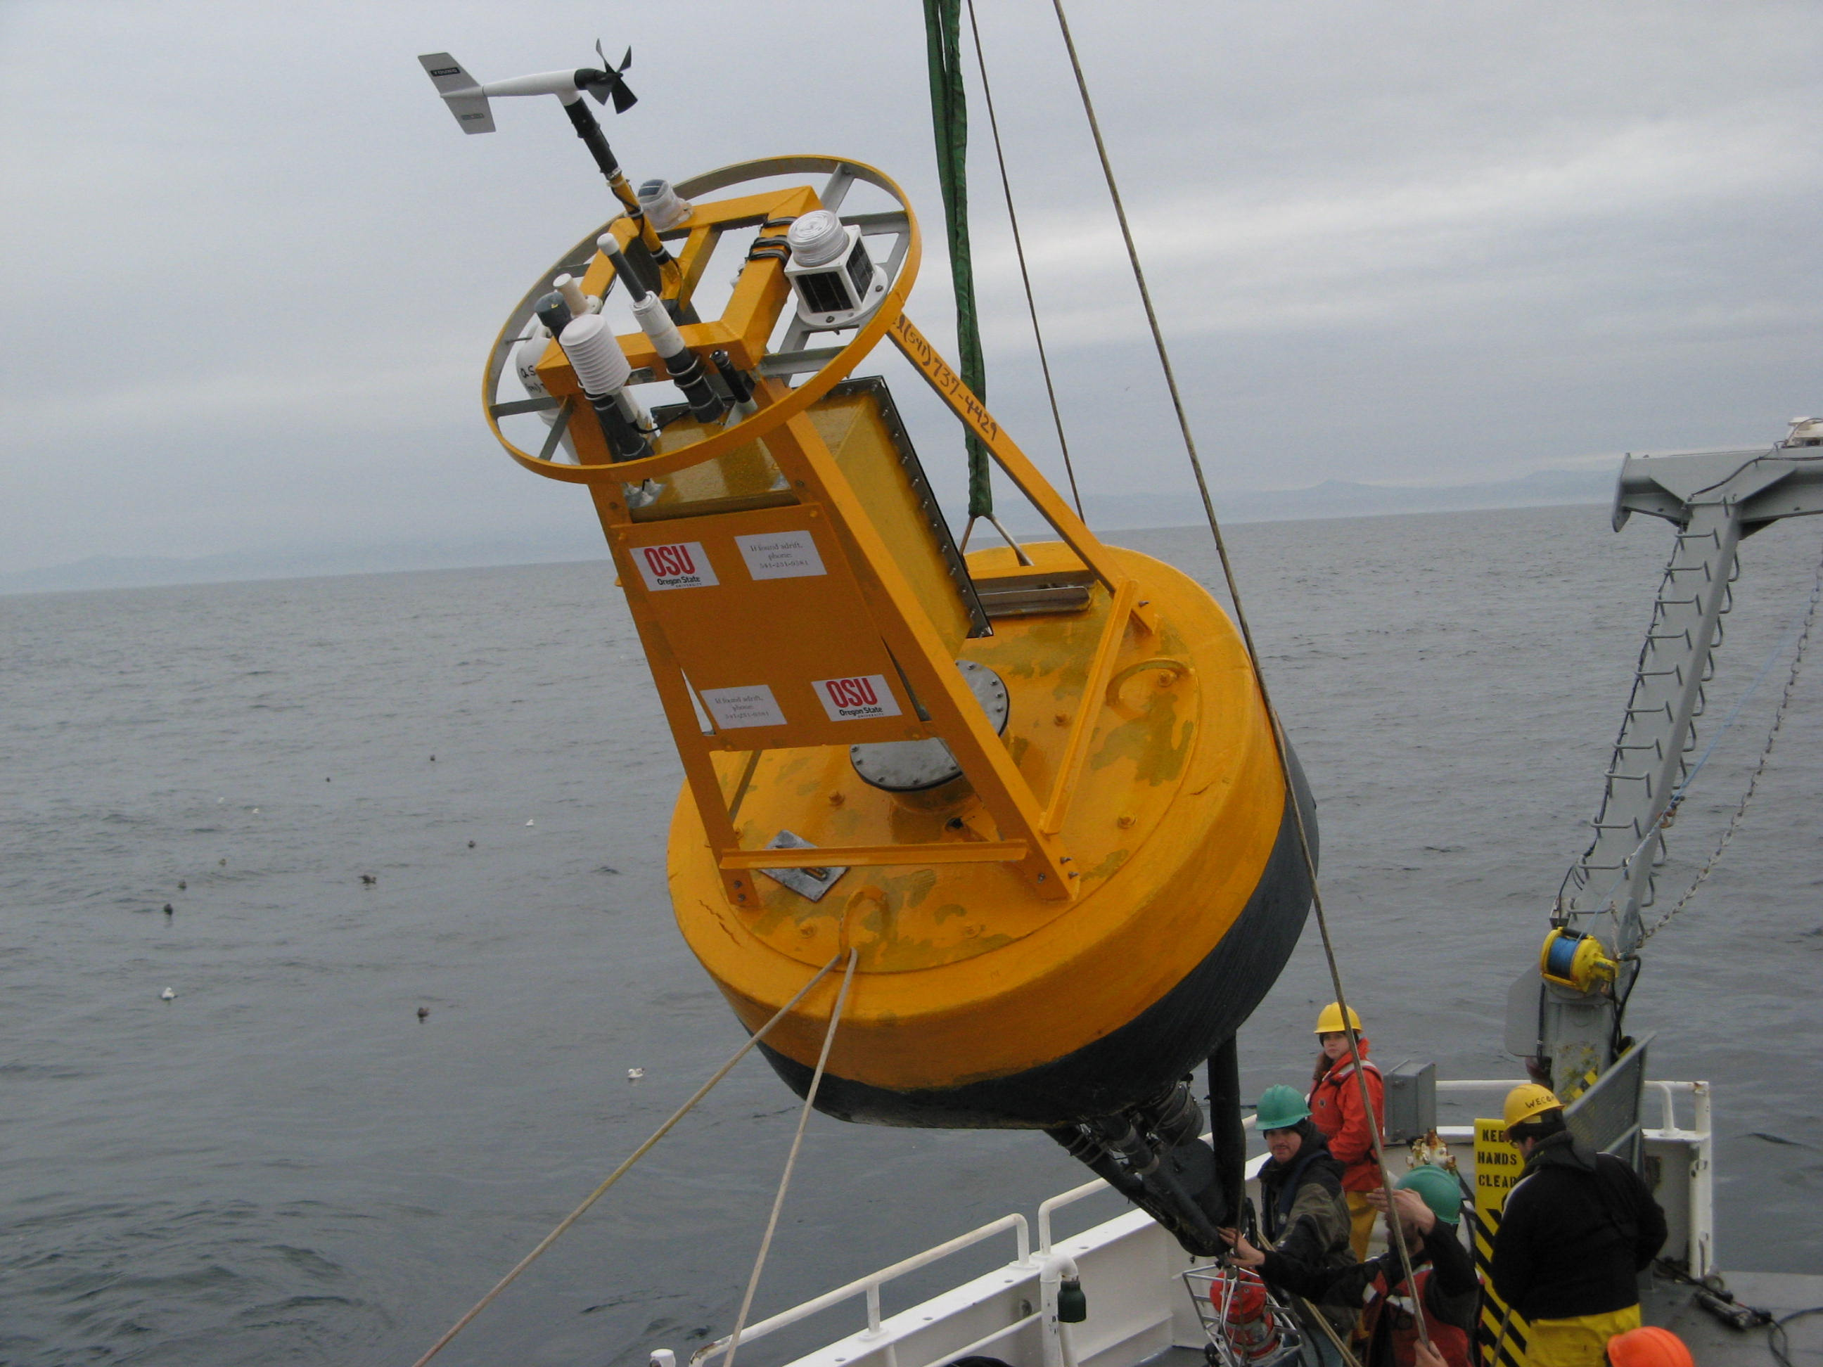

Buoy Alder as deployed in March 2009

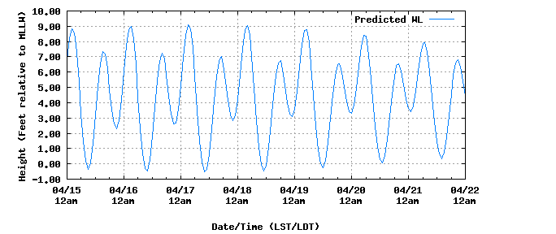

High/Low Tide Predictions in Feet
from 2010/04/15 - 2010/04/21

Tidal Currents, Tongue Pt.
04/15 | Thu | 02:12 AM | 8.87 H
04/15 | Thu | 09:05 AM | -0.35 L
04/15 | Thu | 03:22 PM | 7.4 H
04/15 | Thu | 08:52 PM | 2.3 L
04/16 | Fri | 02:42 AM | 9.03 H
04/16 | Fri | 09:41 AM | -0.53 L
04/16 | Fri | 04:06 PM | 7.24 H
04/16 | Fri | 09:27 PM | 2.55 L
04/17 | Sat | 03:14 AM | 9.11 H
04/17 | Sat | 10:20 AM | -0.57 L
04/17 | Sat | 04:51 PM | 7.03 H
04/17 | Sat | 10:04 PM | 2.8 L
04/18 | Sun | 03:51 AM | 9.07 H
04/18 | Sun | 11:02 AM | -0.48 L
04/18 | Sun | 05:42 PM | 6.8 H
04/18 | Sun | 10:48 PM | 3.05 L
04/19 | Mon | 04:35 AM | 8.86 H
04/19 | Mon | 11:52 AM | -0.24 L
04/19 | Mon | 06:38 PM | 6.62 H
All times listed are in Local Time, Daylight Saving Time has been applied when appropriate. All speeds are in knots.
Flood Direction, 077 True. | Ebb (-)Direction, 249 True.

 | Slack | Max  Curr |  | Slack | Max | Cur | Slack | Max | Cur | Slack | Max | Cur
17 |  | 0114 | +0.8 | 0335 | 0732 | -3.3 | 1252 | 1413 | +0.9 | 1701 | 2001 | -1.9
18 | 0039 | 0152 | +0.8 | 0411 | 0813 | -3.2 | 1338 | 1457 | +0.9 | 1751 | 2048 | -1.7

