APPENDIX 2

CRUISE PLAN R/V WECOMA

Oregon State University
College of Oceanic & Atmospheric Sciences

FILING DATE: | 18 May 2010
CRUISE NUMBER: | W1005A
TITLE: | Science and Technology Center for Coastal Margin Observation and Prediction (CMOP)
CONTRACT/GRANT NUMBER: | NSF
PRINCIPAL INVESTIGATOR(S): | Antonio M. Baptista et al.

PURPOSE: (Short, non-technical statement on how cruise relates to overall project)
The goals of R/V Wecoma operations are:
- Occupy a grid of stations over the Oregon and Washington continental shelf and slope to measure hydrographic (T, S, pressure), bio-optical (chlorophyll fluorescence, light transmission) and chemical (nitrate, dissolved oxygen) parameters. Combine these data with ADCP measurements of subsurface velocity to explore biophysical interactions.
- Collect water samples across environmental gradients in pelagic environments of the Columbia River and its estuary, the Columbia River plume, and along established sampling lines along the Oregon and Washington coasts for DNA- and RNA-based microbial community analyses and study of phytoplankton assemblage structure, harmful algae and phycotoxin as well as chemistry studies (e.g. CH₄, Mn).
- To determine which bacterial assemblage is associated with which particle size in and out of estuarine turbidity maxima, Owen tubes will be used to collect bottom water at Beaver Army Dock and in North and South channels of the Columbia River estuary.
- Make continuous measurements of surface water chemistry with several devices attached to the continuous flow seawater system.
- Collect contextual physical and chemical data with AUV and boom mounted ADCP in estuary and plume

ITINERARY: (Include station positions and route waypoints. Please send/fax/or bring a PAGE SIZE CRUISE TRACK for submission to UNOLS).
Please see attached

WILL RADIOACTIVE METHODS BE USED? | X | YES |  | NO
If so, list OSU radiation use authorization number: Applied For

WILL YOU BE BRINGING HAZARDOUS MATERIALS ABOARD? | X | YES |  | NO
If so, you are responsible for providing the Master with an Inventory of such materials & associated MSDS sheets.

SAMPLING PLAN:
Please see attached for more details

- On the coast and Columbia River plume we will do some CTD casts and at selected casts also collect water using the rosette of the Wecoma CTD unit (12 bottles of 10L each).
- In the estuary we will use a small estuary CTD unit consisting of stainless steel Sea-Bird CTD frame set in a cage that we will provide. This cage has hydrodynamic flaps to keep the CTD package from spinning in the strong currents of the estuary. Heavy weights are attached at the bottom of the cage and the end of a length tubing is attached to the leading end of the cage (see picture 1). Tubing will be clipped to the CTD wire every 3 meters during the cast. This tubing will be removed when water samples are not required. This CTD unit will be equipped with the following sensor that we will provide: FLNTU / O2 / LISST.
- During leg-1 at several stations on the coast and plume Tow net will be done by manually dragging the net along the ship once the ship is on station (no winch required).
- AUV operation in North Channel of Columbia River estuary and plume – REMUS 100. Daylight operation with deployment and recovery of AUV using the ship’s RHIB. Three acoustic transponders will also be deploy to help the AUV navigate.
- Estuarine Turbidity Maximum (ETM) work in Columbia River Estuary. For this the Wecoma would need to be on station for several hours either in North Channel or in South channel at the Anchorage. CTD cast will be done every 30 min and bottom water (1m from bottom) and bottom water will be collected before, during and after ETM event using both a Pacer pump linked to the small estuary CTD unit and Owen tubes.
- Methane outwash experiment in Columbia River Estuary. For this the Wecoma would need to be anchored for ~6hr blocks of time at RM17 in the South channel anchorage. Surface and bottom water will be collected hourly over this ebb tide periods using a Pacer pump linked to the small estuary CTD unit.
- Methane oxidation experiments: deck incubations will also be conducted at 5 locations in the river/estuary and 1 in the plume.
- Plume Methane Survey (both Columbia River line and Plume surveys) will take place at night and will start once AUV work is finished each day. These surveys of the plume (in a prescribed radiator pattern) will consist of collecting throughout the night methane data with the Fast Methane Analyzer plumbed into the ship’s uncontaminated flow-thru water system (no CTD casts).
- Boom mounted ADCP will used on the port side with an additional transductor added. This will be deployed intermittently in estuary and plume during Leg2 (will not be deployed during transit).

EQUIPMENT REQUIRED: (Should be included on Shared-Use Equipment request form)
Equipment List /R/V Wecoma /for/ /May cruise (21May-04Jun 2010)
Standard Ship’s Outfit
a. SeaBird CTD system with transmissometer, fluorometer, PAR, O2, altimeter.
b. SBE Carousel samplers - 12 bottles. 10L bottles
c. RDInstruments shipboard Doppler current profilers; Frequency 75/300 kHz. Dual system required.
d. DAS shipboard data logging/display system
e. Shipboard networking services
f. Winch slip rings - 4-conductor – for CTD
g. Dry Lab tables and cabinets in various heights and sizes
h. Portable refrigerator (15 cu. ft.)
i. Portable chest freezers (2 @ 7 ft³ )
Transient Equipment
j. Low Temperature freezer (1 available) -85C, 5 cu. ft.
Ship’s Deck Equipment
k. Hydro Winch: 0.322” 3-conductor EM for CTD, 1000m max depth.
l. Hydro A-Frame for deploying CTD and Niskin Bottles
m. Stern A-frame for Owen tubes operations
n. Gifford block mounted on A-frame for Owen tubes
Vans
q. Storage Van
r. New Radiation Laboratory Van

29 Mar 2010, Lydie Herfort

Leg 1 = 20May-27May
SCIENTIFIC PERSONNEL TO BE ONBOARD: (Provide full legal name & affiliation)
Scientist in Charge: | Lydie Herfort (OHSU)
Other Scientist(s): | Charles Seaton (OHSU), Francois Ribalet (UW), Maxime Bridoux (UW)
Party Chief:
Technicians: | Vikki Campbell (OHSU), Toby martin (OSU)
Grad Students: | Suzanne DeLorenzo (OHSU), Pete Kahn (OHSU), Nirzwan Bandolin (OHSU), Michelle Maier (OHSU), Sara Bender (UW), Gwenn Hennor (UW), David Needham (USC)
Undergraduate Students:
Observers:

Leg 2 = 28May-04Jun
SCIENTIFIC PERSONNEL TO BE ONBOARD: (Provide full legal name & affiliation)
Scientist in Charge: | Lydie Herfort (OHSU)
Other Scientist(s): | Charles Seaton (OHSU), Craig McNeil (UW), Trina Lichendorf (UW), Andrey Shcherbina (UW), Fred Prahl (OSU)
Party Chief:
Technicians: | Vikki Campbell (OHSU), Troy Swanson (UW), Toby Martin (OSU)
Grad Students: | Suzanne DeLorenzo (OHSU), Pete Kahn (OHSU), Nirzwan Bandolin (OHSU), Michelle Maier (OHSU), Matt Wolhowe (OSU)
Undergraduate Students:
Observers:

OSU Marine Technician(s) Assigned to Cruise: | David Langner

USER SUPPLIED EQUIPMENT:
Vans/Containers:
Number:
Size:
Estimated Weight:
Location:

OTHER BULKY HEAVY ITEMS:
Location:
Estimated Weight:

BILLING INFORMATION:
Name:
Address:
City, State, Zip
Phone:
Account Number (or number to reference):

DO YOU WANT CELLULAR/INMARSAT PHONE ACCESS: | X | YES |  | NO
Chief Scientist will be responsible for all charges – dedicated science phone.

CMOP cruise plan
Oregon & Washington Coasts and Columbia River, Plume & Estuary R/V Wecoma
21May-04June 2010

Area of Operations: Pacific Northwest coastal ocean from South Oregon to North Washington, Columbia River plume, Columbia River and its estuary

Scientific personnel.

For Leg 2 - 29 May only: Watches: Day (7:00-19:00) /Night (01:00-07:00 and 19:00-22:00)
Night watch team: Suzanne DeLorenzo (leader), Matt Wolhowe and Toby Martin

We request copies of all calibration/information sheets for R/V Wecoma instruments.

Shifts and Activities

Leg 1 – 20May-27May:

Only day watch (no night CTD watch)

Leg1 operation details:
- CTD deployment (Lydie Herfort, Charles Seaton, and David Langner)
- Water samples processing for Microbiology Basic Sampling Scheme:
- Dissolved and particulate chemistry (Pete Kahn)
  - Nitrate plus Nitrite, Nitrite, Ammonia, Phosphate, Dissolved Silica
  - Total dissolved nitrogen & phosphorous
  - Dissolved organic carbon
  - Total suspended solids
  - Particulate organic carbon and nitrogen
  - Chlorophyll and other phytoplankton pigments
- DNA and RNA samples (Suzanne DeLorenzo)
- Lugol and formalin fixations (Suzanne DeLorenzo)
- Bacterial Production measurements in radioisotope van (Vikki Campbell)
- Nitrogen fixation incubations (Lydie Herfort & Vikki Campbell, with advise from Michelle Maier)
- Stable Isotope Probing incubations (DeLorenzo)
- SeaFlow (Francois Ribalet)
- FlowCAM (Michelle Maier)
- Harmful Algae Bloom (Pseudo-nitzschia and domoic acid) (Michelle Maier)
- Nitrogen use by phytoplankton (Sara Bender)
- Silica cycling (Gwenn Hennor)
- Diatom lipids (Maxime Bridoux)
- LISST manual measurements (Nirzwan Bandolin)
- Viruses (David Needham)
- ISUS (Charles Seaton)
- Model data (Lydie herfort, Charles Seaton)

Leg 2 – 28May-04Jun:

CTD night watch details:
- CTD night watch is only necessary on 29May for the Major Ebb tide Methane Outwash study in estuary South channel at RM-17 (01:00-07:00) and Minor Ebb tide Methane Outwash study in estuary South channel at RM-17 (19:00-22:00) as subsequent night methane studies will not require CTDs since the focus will be on Fast Methane Analyzer data and on the calibration these data with flow-through water.
- Watches: Day (7:00-19:00) /Night (01:00-07:00 and 19:00-22:00)
- CTD/Methane night watch team: Suzanne DeLorenzo (leader), Matt Wolhowe and Toby Martin.
- CTD night watch ends at 22:00 on 29May, and Suzanne will next rejoin the day team for North_Channel_ETM_Study1 on 30May at 10:00, while Matt will remain on night watch for FMA calibrations using flow through water. Toby CTD duty ends here.

Leg2 operation details:
- CTD deployment
- Day Shift (Lydie Herfort, Charles Seaton, and David Langner)
- Night Shift (Suzanne DeLorenzo (leader), Matt Wolhowe and Toby Martin) (29May only)
- Water samples processing for Microbiology Basic Sampling Scheme:
- Dissolved and particulate chemistry (Pete Kahn)
  - Nitrate plus Nitrite, Nitrite, Ammonia, Phosphate, Dissolved Silica
  - Total dissolved nitrogen & phosphorous
  - Dissolved organic carbon
  - Total suspended solids
  - Particulate organic carbon and nitrogen
  - Chlorophyll and other phytoplankton pigments
- DNA and RNA samples (Suzanne DeLorenzo, apart from 28-29May = Vikki Campbell)
- Lugol and formalin fixations (Suzanne DeLorenzo, apart from 28-29May = Pete Kahn)
- Bacterial Production measurements in radioisotope van (Vikki Campbell)
- FlowCAM (Michelle Maier)
- Chytrid/phytoplankton study(Michelle Maier)
- LISST attached to small estuarine CTD but manual measurements in plume (Nirzwan Bandolin)
- Nitrogen fixation and Methane incubations (Michelle Maier)
- Methane study for water where incubations are done: Sterivex, SPM and nutrient
- Day Shift (Vikki Campbell and Pete Kahn)
- Night Shift (Suzanne DeLorenzo) (at 06:00 on 29May)
- Methane GC measurements
- Day Shift (Fred Prahl)
- Night Shift (Matt Wolhowe)
- Fast Methane Analyzer (Fred Prahl and Matt Wolhowe)
- Fast Methane Analyzer (Fred Prahl and Matt Wolhowe)
- AUV (Craig McNeil, Trina Litchendorf, Troy Swanson, Andrey Shcherbina)
- O₂-Winkler titrations (AUV team with help from Microbiology team)
- Boom-mounted ADCP (Lydie Herfort, Charles Seaton)
- Model data (Lydie herfort, Charles Seaton and Craig McNeil)

Surface and bottom sampling:
Surface is defined for all as 2 and 1 m from surface in coast/plume and estuary/river, respectively
Bottom is defined for all as 5 and 1 m from bottom in coast/plume and estuary/river, respectively

Sampling details for Owen tubes:
Bottom water (1m from bottom) will be collected at Beaver Army Dock and at ETM sites (SC-ETM & NC-11) in North and South channels of the Columbia River estuary. Four settling fractions will be settled (#1: 5.75min, #2: 19.25min, #3: 40.5min, #4: immediately thereafter). Deployment and sampling will take about 90 min. Whole water collected with pacer pump will be processed according to the Microbiology Basic Sampling Scheme, but note that dissolved chemical will also be collected directly from the Owen tube fraction because Owen tubes and Pacer pump water collection will not be done exactly at the same place on the ship.

3L of water will be collected for each fractions:
- 1L for SPM and δC/N (Pete Kahn)
- 1900mL for 2 Sterivex (both fixed with RNAlater) (S. DeLorenzo, apart from 28-29May = V. Campbell)
- 100mL for bacterial production (Vikki Campbell)
- Use filtrate of Sterivex to collect samples for NUT, DOC, TDN/P (DeLorenzo/ Campbell)

Owen tube sampling of bottom water will be done at:
- Beaver Army dock (28May)
- SC-ETM at peak ETM (29May)
- NC-11 at pre-ETM (10:00 on 30May)
- NC-11 at peak ETM (30May)
- NC-11 at post ETM (15:30 on 30May)
- NC-11 at pre-ETM (11:00 on 31May)
- NC-11 at peak ETM (31May)
- NC-11 at post ETM (16:00 on 31May)

6 Methane incubation experiments:
INCUB 1: Beaver (day - 28 May) Depth: surface (1a) and bottom (1b) Fred, Michelle
INCUB 2: UPRIVER#2 (day - 28 May) Depth: surface (2) Fred, Michelle
INCUB 3: RM17 (6:00) (night - 29 May) Depth: surface (3a) and bottom (3b) Matt, Michelle, Fred
INCUB 4: RM17 (18:00) (day - 29 May) Depth: surface (4a) and bottom (4b) Fred, Michelle, Matt
INCUB 5: NC ETM (day - 30 May) Depth: ETM peak/bottom (5) Fred, Michelle, Matt
INCUB 6: Plume survey (night - 31 May) Depth: surface; from Flow-through (6) Fred, Michelle, Matt
**NOTE: Upriver#2 might be changed for Upriver #3 or 4 depending on how the setup at Beaver Army Dock went

Collect water into a carboy with Pacer Pump (or Flow-through for Plume sample) and sub-sample from 20L carboy for:
- Methane oxidation incubations (Michelle Maier)
- 4 Sterivex fixed with RNAlater, 2 SPM filters and 2 bottles for nutrient. **NOTE: use consumable provided by Methane team.
- Day Shift (Vikki Campbell and Pete Kahn)
- Night Shift (Suzanne DeLorenzo) (at 06:00 on 29 May)

Samples for [CH4] to be drawn from small tubing inserted into PVC tube attached to Pacer pump:
- GC measurements
- Day Shift (Fred Prahl)
- Night Shift (Matt Wolhowe)

Leg2_Plume_Studies water sampling:
For each of these 3 days, one full AUV track will be done with Wecoma per day during the time the AUV is in the water. Seven CTD casts collecting water at 6 depths will be done along the AUV path (4 nautical miles).
- Nutrient will be collected at all 6 depths
- For gene expression microarray study, water will be collected at surface and bottom and processed according to the “Microbiology Basic Sampling Scheme”.
- O₂ measurements (Winkler titration) will be done at a sub-set of depths by AUV team with help from Microbiology team.
- For phytoplankton study, at every other stations samples will be collected for FlowCAM analysis (50mL) at the surface and from near the bottom (where the water would enter the estuary) to coincide with the nutrient samples will be collected. A Lugol's sample (100 mL), a POC/PN sample (500 mL) will also be collected at these depths.

**NOTE: No methane measurements have been planned during Leg2_Plume_Studies.

Cruise Plan

20 May 2010
08:00 Loading day in Newport. OHSU (including chief scientists) team will arrive at 11:00. Boom mounted ADCP will arrive at ?. UW team will arrive at ?.
21 May 2010
10:00 Leave Dock and travel to SH-10
11:00 Finish Safety Drills
12:30 Begin Strawberry Hill Line transect (CTD & water at 7 stations)
21:00 Transit to NH-1
.
22 May 2010
06:00 Begin Newport Hydroline transect (CTD & water at 10 stations, Tow net at 3 sites)
17:30 Transit to CM-1

23 May 2010
06:00 Begin Cape Meares Line transect (CTD & water at 9 stations)
17:00 Transit to LP-4

24 May 2010
06:00 Begin LaPush Line transect (CTD & water at 9 stations, Tow net at 3 sites)
16:30 Transit to GH-41

25 May 2010
06:00 Begin Gray’s harbor Line transect (CTD & water at 8 stations)
14:30 Transit to WB-5
16:30 Begin Willapa Bay Line transect (CTD & water at 3 stations)
18:30 Transit to CR-4

26 May 2010
06:00 Begin Columbia River Line transect (CTD & water at 10 stations, Tow net at 3 sites)
16:00 Transit to CR-7

27 May 2010
06:00 Begin Leg1_Plume_Study (CTD, water and Tow net at 4 sites) with first station being CR-7. Exact location of other 3 sites (P-1, P-2, P-3) in plume will be given by Modeling team no later than 19:00 on 26 Mar 2010 aiming for 20, 25, 28 PSU.

10:30 Transit to Astoria dock

12:00 Dock in Astoria, partial scientific crew change, loading and unloading of equipment (switch to small estuary CTD)

28 May 2010
05:30 Transit to RM-8 in estuary South Channel (sunrise at 05:28)

06:00 Begin transects along salinity gradient in South Channel (CTD & water at 4 stations) and transit to Beaver Army Dock
**NOTE: Microbiology sampling team needs to be up for this early sampling. Although DeLorenzo will not sample on 28May, in preparation of night watch on 29May she will take part in a couple of CTDs deployments during this day to get familiarized with the small estuary CTD unit.

13:00 CTD and water (surface and bottom) at Beaver Army Dock for Microbiology Basic Sampling Scheme and Methane. Owen tubes will also be deployed to collect bottom water.

13:30 Begin Methane_Down_River_Survey (CTD & water at 8 stations), time no less than 1 hour between stations because samples take 1 hour to be processed.

21:00 Last CTD of Methane_Down_River _Survey at RM-17.

Overnight anchor at RM-17 (sunset at 20:49) and deploy Boom-mounted ADCP

29 May 2010
01:00 Begin Major Ebb tide Methane Outwash study in estuary South channel at RM-17 (CTD & water every hour)
**NOTE: night watch CTD & methane team: Suzanne DeLorenzo (leader), Matt Wolhowe and Toby Martin

09:00 Last CTD of Major Ebb tide Methane Outwash study

09:15 Deploy RHIB for AUV team to go set up acoustic transponder in North channel in preparation of the following day AUV work

09:45 Transit to SC-ETM (next to Buoy 39 - still in Anchorage)

10:00 Begin Flood tide South_Channel_ETM_Study at SC-ETM (CTD every 30 min, bottom water collected with Pacer pump before, during and after ETM event and with Owen tubes during ETM)

14:15 Return of AUV team and recovery of RHIB

14:45 Transit to RM-17 and anchor

15:00 Begin of Minor Ebb tide Methane Outwash study at RM-17 (CTD & water every hour)
**NOTE: night watch ends at 22:00, Suzanne will next rejoin the day team for North_Channel_ETM_Study1 on 30May at 10:00, while Matt will remain on night watch for FMA calibrations using flow through water. Toby’s CTD duty ends here.

22:00 Begin Night Flood tide Methane Outwash study at RM-17 (no CTD but water collected every hour from flow-thru to check FMA calibration)

30 May 2010
02:00 Begin Night Ebb tide Methane Outwash study at RM-17 (no CTD but water collected every hour from flow-thru to check FMA calibration)
**NOTE: the full ebb tide will not be sampled because we have to be at NC-11 at 09:00.

05:30 Recover boom-mounted ADCP and transit to estuary North channel at NC-11 and anchor

09:00 Deploy boom-mounted ADCP and RHIB for AUV deployment in estuary North channel

09:45 Recover RHIB

10:00 Begin Flood tide North_Channel_ETM_Study1 (CTD every 30 min, bottom water collected with both Pacer pump and Owen tubes before, during and after ETM event). At peak ETM, also collect bottom water for Mn study.

16:00 Last CTD of North_Channel _ETM_Study1

16:15 Deploy RHIB for AUV recovery (the 3 transponders stay in water for the following day AUV work)

17:30 Begin of Night Ebb tide Methane study at NC-11 (no CTD but water collected every hour from flow-thru to check FMA calibration).
**NOTE: Methane study cannot start until AUV and RHIB are recovered.

22:00 Begin of Night Flood tide Methane study at NC-11 (no CTD but water collected every hour from flow-thru to check FMA calibration)

31 May 2010
09:45 End of Night Flood tide Methane study at NC-11

10:00 Deploy RHIB for AUV deployment in estuary North channel

10:45 Recover RHIB

11:00 Begin Flood tide North_Channel _ETM_Study2 in (CTD every 30 min, bottom water collected with both Pacer pump and Owen tubes before, during and after ETM event).

16:15 Last CTD of North_Channel _ETM_Study2 and swap small estuary CTD for Wecoma CTD with rosette

16:30 Deploy RHIB for recovery of both AUV and the 3 transponders.

18:30 or as soon as transponders and AUV are recovered, recover RHIB and boom-mounted ADCP, leave NC-11, pass bar and sail to CR-7 (sunset at 20:51)

20:30 Sail off shore to discharge waste.

Return to plume area and begin Plume_Methane_Survey1 in a prescribed radiator pattern (no CTD, data collected with Fast Methane Analyzer). Exact coordinates of Plume_Methane_Survey1 will be provided by the modeling team before lunch time (19:00) on 30 May 2010 (coordinates and time, with one site per hour). The exact start (time and location) of Plume_Methane_Survey1 will depend on how long it will take us to recover AUV and transponders. To give flexibility, modeling team with provide coordinates for every hour from 19:00 on 31 May until 08:00 on 01 Jun, so for example, if Wecoma return to plume at 22:00, skip first few coordinates and start with coordinate at 22:00 from the list provided by modeling team).

01 Jun 2010
07:00 Do one CTD cast at the beginning of AUV track to collect surface water for N2_fixation study

Begin Leg2_Plume_Study1 (AUV and water collection). AUV mission track will be across the plume and exact positions will be determined based on modeling predictions before 15:00 on 31 May. To deploy the transponders in the correct location and depth for the AUV mission, Wecoma will do a 'drive by' the planned AUV path to get a sounding depth, which will then be used this to set the line depth for the transponders.

Deploy RHIB to first deploy transponders at correct locations in plume and then AUV.

Once the 3 transponder and AUV1 are deployed, recover RHIB and deploy boom-mounted ADCP.

Begin Leg2_Plume_Study1 with Wecoma tracking the AUV1 (keep Wecoma 'up current' of the AUV) (7 CTD casts along the 4 nautical miles AUV path, with water collected at 6 depths for Nutrient, at surface and bottom for Microbiology Basic Sampling Scheme and Phytoplankton study, and at a subset of depths for O₂ measurements by Winkler). Collect one plume surface water sample for Mn study.

At the end of mission, Deploy RHIB to recover AUV1

20:00 Deploy AUV2 (while AUV1 is recharging) and leave AUV2 and the 3 transponders in plume overnight

Once AUV2 is deployed, recover RHIB and boom-mounted ADCP and Begin Plume_Methane_Survey2 in a prescribed radiator pattern (no CTD, data collected with Fast Methane Analyzer). Exact coordinates of Plume_Methane_Survey2 will be provided by the modeling team at19:00 on 31 Jun 2010 (coordinates and time, with one site per hour). The exact start (time and location) of Plume_Methane_Survey2 will depend on how long it will take us to recover and redeploy AUVs. To give flexibility, modeling team with provide coordinates for every hour from 18:00 on 01 Jun until 07:00 on 02 Jun).

02 Jun 2010
07:00 Do one CTD cast at the beginning of AUV track to collect surface water for N2_fixation study

07:30 Deploy RHIB to recover AUV2, deploy AUV1 and boom-mounted ADCP and begin Leg2_Plume_Study2 (same location at previous day) with again Wecoma tracking the AUV, doing 7 CTD casts along the 4 nautical miles AUV path, with water collected at 6 depths for Nutrient, at surface and bottom for Microbiology Basic Sampling Scheme and Phytoplankton study, and at a subset of depths for O₂ measurements by Winkler. Depending on the weather, if the transponders’ position has changed a lot overnight, it might be necessary to reposition them correctly before restarting the AUV mission.

17:00 Deploy RHIB to recover AUV and transponders . Note that depending on the results from the overnight AUV deployment of the previous day, we might decide to again carry out an ovbernight AUV deployment.

20:15 Recover RHIB (or sooner if recovery of transponders and AUV is accomplished earlier) and recover boom-mounted ADCP.

20:30 Begin Columbia River Line transect (no CTD, data collected with Fast Methane Analyzer). NOTE: this may have to be started later if AUV work requires more time, in which case CR-50 might have to be skipped to make it back to the plume area for 07:00 on 03 Jun 2010.

03 Jun 2010
07:00 Deploy Boom Mounted ADCP and begin Leg2_Plume_Study3 (AUV and water collection). This new AUV mission track will be across the plume and exact positions will be determined based on modeling predictions before 21:00 on 02 Jun. This will be a different track than the previous two days.

To deploy the transponders in the correct location and depth for the AUV mission, Wecoma will do a 'drive by' the planned AUV path to get a sounding depth, which will then be used this to set the line depth for the transponders.

Deploy RHIB to first position transponders at correct locations in plume and then AUV.

Once the 3 transponder and AUV are deployed, recover RHIB.

Begin Leg2_Plume_Study3 with Wecoma tracking the AUV (keep Wecoma 'up current' of the AUV), with again Wecoma tracking the AUV, doing 7 CTD casts along the 4 nautical miles AUV path, with water collected at 6 depths for Nutrient, at surface and bottom for Microbiology Basic Sampling Scheme and Phytoplankton study, and at a subset of depths for O₂ measurements by Winkler.

17:00 Deploy RHIB to recover AUV and transponders

20:15 Recover RHIB (or sooner if recovery of transponders and AUV is accomplished earlier) and recover boom-mounted ADCP

20:30 Begin the short Plume_Methane_Survey3 in a prescribed radiator pattern (no CTD, data collected with Fast Methane Analyzer). Exact coordinates of Plume_Methane_Survey2 will be provided by the modeling team at 19:00 on 02 Jun 2010 (coordinates and time, with one site per hour). The exact start (time and location) of Plume_Methane_Survey2 will depend on how long it will take us to recover AUV and transponders. To give flexibility, modeling team with provide coordinates for every hour from 18:00-22:00 on 03 Jun.

22:00 Transit to Newport

04 Jun 2010
07:00 Dock in Newport and unload

List of CTD stations:

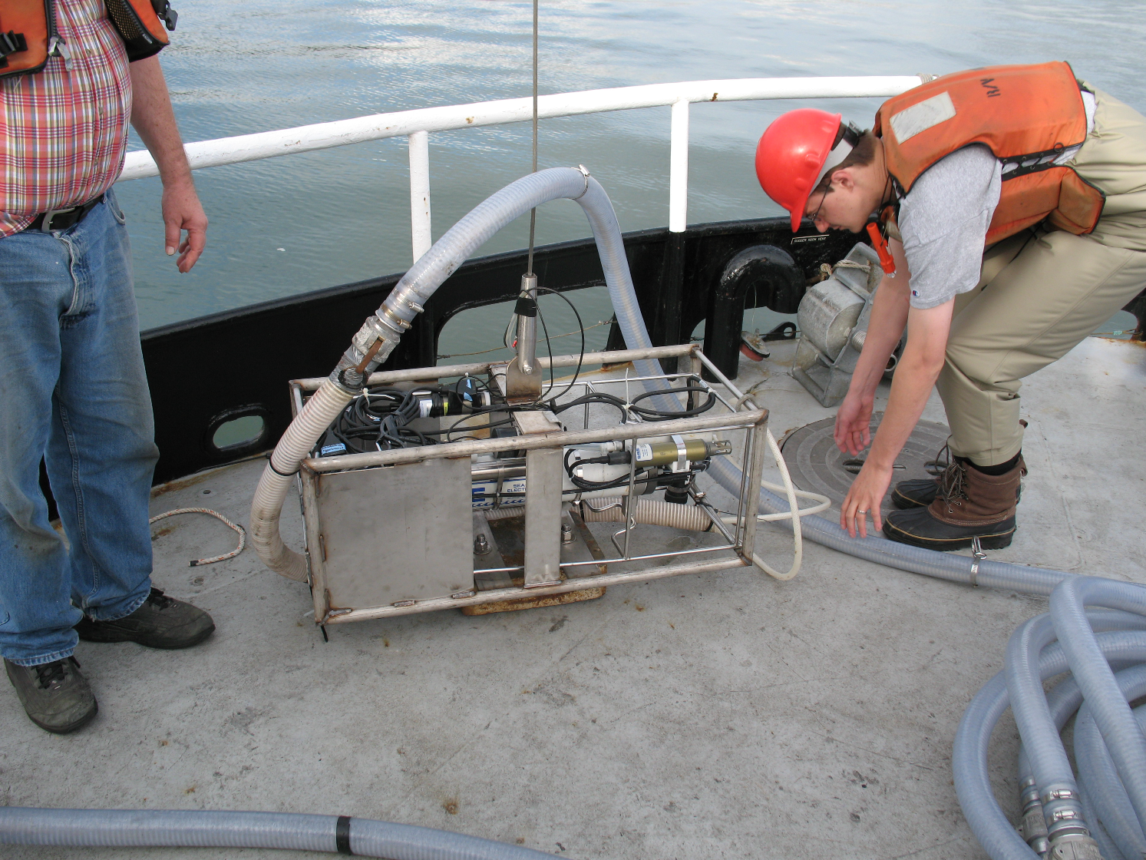
Picture 1. Small estuary CTD unit consisting of stainless steel Sea-Bird CTD frame set in a cage that we will provide. Tubing is clipped to the CTD wire every 3 meters during the cast. This tubing will be removed when water samples are not required. This CTD unit will be equipped with the following sensor that we will provide: FLNTU / O2 / LISST.

Tidal charts:

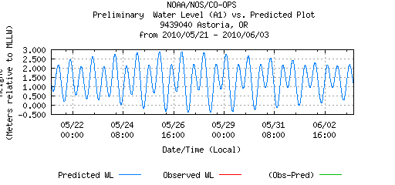

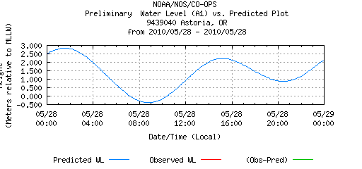

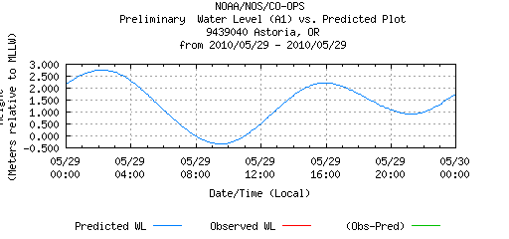

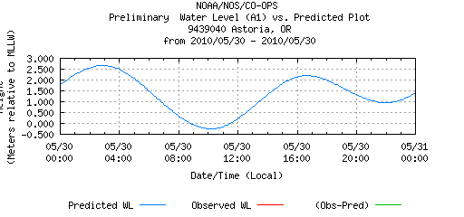

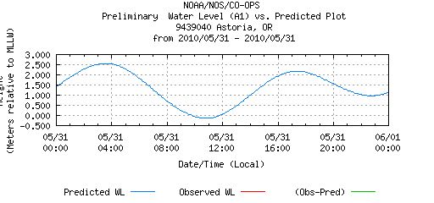

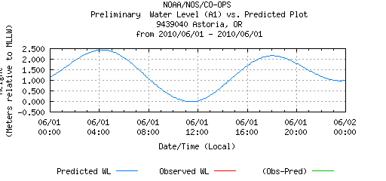

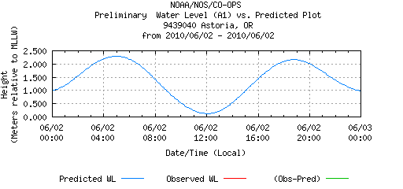

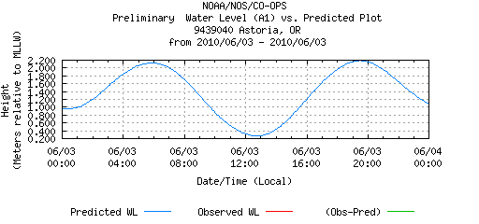

Sample collection for Leg1:

Con’t - Sample collection for Leg1:
Sample collection for Leg2:

N.D. = not determined

Con’t - Sample collection for Leg2:

CTD = water collected with pacer pump linked to small estuary CTD
FT = water collected via flow-through system

N.D. = not determined

