APPENDIX 2

CRUISE PLAN R/V WECOMA

Oregon State University
College of Oceanic & Atmospheric Sciences

FILING DATE: | 6 August 2007
CRUISE NUMBER: | W0708B
TITLE: | Science and Technology Center for Coastal Margin Observation and Prediction (CMOP)
CONTRACT/GRANT NUMBER: | NSF
PRINCIPAL INVESTIGATOR(S): | Antonio M. Baptista, John A. Barth, David L. Martin, Bruce A. Menge, Peter Zuber

PURPOSE: (Short, non-technical statement on how cruise relates to overall project)
The goals of R/V Wecoma operations are:
- Mooring placement at station NH-10 along the Newport Hydroline.
- Occupy a grid of stations over the Oregon and Washington continental shelf and slope to measure hydrographic (T, S, pressure), bio-optical (chlorophyll fluorescence, light transmission) and chemical (nitrate, dissolved oxygen) parameters. Combine these data with ADCP measurements of subsurface velocity to explore biophysical interactions.
- Collect water samples for DNA- and RNA-based microbial community analyses and water chemistry studies across environmental gradients in pelagic environments of the Columbia River estuary, the Columbia River plume, and along established sampling lines along the Oregon and Washington coasts.
- Collect sediment samples with the multicorer at select sites along the Columbia River Line to characterize surface sediment microbial groups of special interest such as Crenarchaeota or Anammox bacteria. Samples will also be taken on other lines if we encounter hypoxic (Low dissolved oxygen) water.
- Make continuous measurements of surface water chemistry with several devices attached to the continuous flow seawater system.
- Collect large-volume DNA samples from hypoxic waters for large-scale environmental cloning/sequencing (J. Craig Venter Institute)
- Conduct a Feature Tracking exercise using the SWAP system and model-based now-cast/forecast system to follow the Columbia River Plume.

ITINERARY: (Include station positions and route waypoints. Please send/fax/or bring a PAGE SIZE CRUISE TRACK for submission to UNOLS).
Please see attached

WILL RADIOACTIVE METHODS BE USED? | X | YES |  | NO
If so, list OSU radiation use authorization number: Applied For

WILL YOU BE BRINGING HAZARDOUS MATERIALS ABOARD? | X | YES |  | NO
If so, you are responsible for providing the Master with an Inventory of such materials & associated MSDS sheets.

SAMPLING PLAN:
Please see attached

EQUIPMENT REQUIRED: (Should be included on Shared-Use Equipment request form)
Please see attached

SCIENTIFIC PERSONNEL TO BE ONBOARD: (Provide full legal name & affiliation)
Scientist in Charge: | Byron Crump (UMCES)
Other Scientist(s): | Murray Levine, Steve Pierce (OSU)  Jim Nurmi (OHSU)  Jude Apple (UMCES)  Lisa Zeigler (JCVI)
Party Chief:
Technicians: | Joanna Green (UMCES)  Walter Waldorf, Craig Risien, Dale Hubbard (OSU)  Christina Tweed, Nate Hyde, Matthew Kalisz (OHSU)
Grad Students: | Carolyn Fortunato (UMCES)  Katelyn R. Nichols (OSU)  Suzanne Delorenzo, Daniel Murphy (OHSU)
Undergraduate Students:
Observers:

OSU Marine Technician(s) Assigned to Cruise: | Dave O'Gorman, Sonya Newell

USER SUPPLIED EQUIPMENT:
Vans/Containers:
Number:
Size:
Estimated Weight:
Location:

OTHER BULKY HEAVY ITEMS:
Location: | Anchor for mooring. Location: Deck.
Estimated Weight: | 2500#

BILLING INFORMATION:
Name:
Address:
City, State, Zip
Phone:
Account Number (or number to reference):

DO YOU WANT CELLULAR/INMARSAT PHONE ACCESS: | X | YES |  | NO
Chief Scientist will be responsible for all charges – dedicated science phone.

CMOP cruise plan
Oregon Coast, Columbia R. Plume and Estuary, Washington Coast
R/V Wecoma
August 14 – August 31, 2007

Area of Operations: Pacific Northwest coastal ocean from South Oregon to North Washington, Columbia River plume, Columbia River estuary

Scientific personnel.
Name | Inst. | Activity | Watch | 14 | 15 | 16 | 17 | 18 | 19 | 20 | 21 | 22 | 23 | 24 | 25 | 26 | 27 | 28 | 29 | 30 | 31 | 1
Levine, Murray | OSU | mooring | D | X
Waldorf, Walt | OSU | mooring | D | X
Risien, Craig | OSU | mooring | D | X
Wet Labs Person |  | mooring | D | X
Crump, Byron | UMCES | Chief Sci | D | X | X | X | X | X | X | X | X | X | X | X | X | X | X | X | X | X | X | X
Apple, Jude | UMCES | water | D | X | X | X | X | X | X | X | X | X
Green, Joanna | UMCES | water | D |  |  |  |  |  |  |  |  |  | X | X | X | X | X | X | X | X | X | X
Fortunato, Caroline | UMCES | water | D | X | X | X | X | X | X | X | X | X | X | X | X | X | X | X | X | X | X | X
Zeigler, Lisa | JCVI | water | D |  | X | X | X | X | X
Delorenzo, Suzanne | OHSU | water | D | X | X | X | X | X | X | X | X | X | X | X | X | X | X | X | X | X | X | X
Murphy, Daniel | OHSU | water | D | X | X | X | X | X | X | X | X | X
Tweed, Christina | OHSU | water | D |  | X | X | X | X | X | X | X | X | X | X | X | X | X | X | X | X | X | X
Hyde, Nate | OHSU | CTD | D or N |  | X | X | X | X | X | X | X | X
Kalisz, Mattthew | OHSU | CTD | D or N |  |  |  |  |  |  |  |  |  | X | X | X | X | X | X | X | X | X | X
Nurmi, Jim | OHSU | Coring, water | D | X | X | X | X | X | X | X | X | X | X | X | X | X | X | X | X | X | X | X
Hubbard, Dale | OSU | Coring, water | D | X | X | X | X | X | X | X | X | X
Hales, Burke | OSU | water | D |  |  |  |  |  |  |  |  |  | X | X | X | X | X | X | X | X | X | X
Nichols, Katelyn | OSU | CTD | D or N | X | X | X | X | X | X | X | X | X | X | X | X | X | X | X | X | X | X | X
Pierce, Steve | OSU | CTD | D or N |  |  |  |  |  |  |  |  |  | X | X | X | X | X | X | X | X | X | X
O’Gorman, Dave | OSU | Mar Tech | D | X | X | X | X | X | X | X | X | X | X | X | X | X | X | X | X | X | X | X
Newell, Sonya | OSU | Mar Tech | N | X | X | X | X | X | X | X | X | X | X | X | X | X | X | X | X | X | X | X
Open Berth |  |  |  |  | O | O | O | O | O | O | O | O | O | O | O | O | O | O | O | O | O | O
Open Berth |  |  |  |  |  |  |  |  |  | O | O | O | O | O | O | O | O | O | O | O | O | O
CS = Chief Scientist; SL = Shift Leader; Watches: Day/Night

R/V Wecoma objectives and operations. The goals of R/V Wecoma operations are:
- Mooring placement at station NH-10 along the Newport Hydroline.
- Occupy a grid of stations over the Oregon and Washington continental shelf and slope to measure hydrographic (T, S, pressure), bio-optical (chlorophyll fluorescence, light transmission) and chemical (nitrate, dissolved oxygen) parameters. Combine these data with ADCP measurements of subsurface velocity to explore biophysical interactions.
- Collect water samples for DNA- and RNA-based microbial community analyses and water chemistry studies across environmental gradients in pelagic environments of the Columbia River estuary, the Columbia River plume, and along established sampling lines along the Oregon and Washington coasts.
- Collect sediment samples with the multicorer at select sites along the Columbia River Line to characterize surface sediment microbial groups of special interest such as Crenarchaeota or Anammox bacteria. Samples will also be taken on other lines if we encounter hypoxic (Low dissolved oxygen) water.
- Make continuous measurements of surface water chemistry with several devices attached to the continuous flow seawater system.
- Collect large-volume DNA samples from hypoxic waters for large-scale environmental cloning/sequencing (J. Craig Venter Institute)
- Feature Tracking exercise using the SWAP system and model-based now-cast/forecast system to follow the Columbia River Plume.
- Schedule coordination with airplane-based remote sensing of Columbia River Plume.

The cruise will begin with mooring placement operations on Aug 14 and return at Newport on the morning of Aug 15 to change scientific crew. Then we will spend 4 days and nights (Aug 15-18) sampling across coastal transects along established lines on the Oregon Coast. On the morning of Aug 19 we will dock in Astoria to change scientific crew and drop off frozen samples. Later that morning we will transit to the northern Washington coast to sample two established lines on Aug 19-20. We will return to the Columbia River mouth for “feature tracking” exercises on Aug 21 using the SWAP system and model-based now-cast/forecast system to follow the Columbia River Plume. The next two days and nights (Aug 22-23) we will sample across the Columbia River Plume at stations to be determined during the cruise using the SWAP system. On the evening of Aug 23 we will return to Astoria to change scientific crew and drop off frozen samples. Early the next morning (~0300) we will transit to the mouth of Willipa Bay to begin sampling two established lines that day and night. Aug 25 is an open day in the schedule. On Aug 26-28 we will conduct CTD casts and collect samples across the salinity gradient in the North and South Channels of the Columbia River estuary. The next two days and nights (Aug 29-30) we will sample across the Columbia River Plume at stations to be determined before and during the cruise. On the evening of Aug 30 we will transit to Newport and offload the ship on Aug 31.

Sampling for microbial community and water chemistry studies will take three forms.
- Daytime operations on coastal and river plume transects will include CTD casts at every station, and water sampling (10L niskins) at five stations. We may have to deploy the CTD twice at water sampling stations in order to get enough water – the second deployment will be to collect surface water. Multicorer sampling will occur at several stations (to be determined) on the Columbia River line on 18-Aug. Water sampling stations may be modified one to two days before cruise. Four 10L niskin bottles will be fired at each of two to five depths depending on results from the CTD downcast.
- Nightime operations on coastal and plume transects will include CTD casts. No water sampling at night.
- Estuary operations will involve transects across the salinity gradient in the north and south channels of the estuary and across the estuary mouth. CTD casts will be conducted to map the salinity structure. Niskin bottles will be used to collect water at a range of salinities from surface and bottom depths at different stages of the tide. We anticipate halting operations during strong ebb tides. No operations at night.

We request copies of all calibration/information sheets for R/V Wecoma instruments.

Shifts and Activities
CTD deployment (suggestion)
- Day Shift
  - David O’Gorman
  - Nate Hyde/Steve Pierce
- Night Shift
  - Katelyn Nichols
  - Sonya Newell
Water samples processing:
- Dissolved and particulate chemistry (nutrients and organic matter)
  - Dissolved Oxygen on a subset of samples for calibration of O2 sensor (Hubbard/Hales, Apple)
  - Dissolved inorganic carbon (Hubbard/Hales)
  - Nitrate plus Nitrite, Nitrite, Ammonia, Phosphate, Dissolved Silica (Fortunato, Nurmi, Tweed)
  - Total dissolved nitrogen & phosphorous (Fortunato, Tweed, Nurmi)
  - Dissolved organic carbon (Fortunato, Tweed, Nurmi)
  - Total suspended solids (Fortunato, Tweed, Nurmi)
  - Particulate organic carbon and nitrogen (Fortunato, Tweed, Nurmi)
- Chlorophyll and other phytoplankton pigments (Fortunato, Tweed, Nurmi)
- DNA and RNA samples (Delorenzo, Murphy/Kalisz, Fortunato)
- Bacterial Production measurements in radioisotope van (Apple/Green)
- Bacterial respiration measurements in deck-top flow-through incubators (Apple/Green)
- Large-volume DNA samples (Zeigler)
Coring:
- Core collection and processing (Hubbard, Nurmi)
Feature Tracking:
- Using SWAP system to track and follow Columbia R. Plume (Hyde, Crump, Others?)

Cruise Plan

14 August 2007
10:00 Liquid Nitrogen safety meeting
10:00 Leave Dock
11:30 Finish Safety Drills, travel to NH-10, begin mooring deployment
15:00 Finish mooring deployment; conduct a few CTD casts with some training; conduct a coring operation with some training.
18:00 Begin monitoring and testing of OSU-WET Labs profiler mooring (deployed previous week). Recover and redeploy if necessary.
15 August 2007
06:00 Return to dock at Newport; scientific crew change
08:00 Leave Dock and Transit to station SH-10
10:30 Begin Strawberry Hill transect (CTD at 9 stations, Niskin bottles at 5 stations)
21:00 Transit to station LB-100
16 August 2007
02:00 Begin Lincoln Beach transect (CTD at 8 stations)
06:00 Transit to station NH-1
08:30 Begin Newport Line transect (CTD at 10 stations, Niskin bottles at 5 stations)
18:30 Transit to station CH-25
22:30 Begin Cascade Head transect (CTD at 8 stations)
17 August 2007
03:30 Transit to station CM-1
07:30 Begin Cape Meares transect (CTD at 10 stations, Niskin bottles at 5 stations)
19:00 Transit to station CF-30
22:30 Begin Cape Falcon transect (CTD at 8 stations)
18 August 2007
04:30 Transit to station CR-4
07:00 Begin daytime Columbia River transect (CTD at 10 stations, Niskin bottles at 5 stations)
20:00 Begin nighttime Columbia River transect (CTD at 10 stations)
19 August 2007
06:30 Transit to Astoria
08:00 Dock in Astoria; scientific crew change, transfer of frozen samples.
12:00 Transit to station QR-3
23:00 Begin Queet’s River transect (CTD at 7 stations)
20 August 2007
05:00 Transit to station LP-52
08:30 Begin La Push transect (CTD at 10 stations, Niskin bottles at 5 stations)
20:00 Transit to station CR-4
21 August 2007
07:00 Begin Feature Tracking exercises
22 August 2007
07:00 Begin Neap Tide Columbia River Plume transects
23 August 2007
16:00 Transit to Astoria
19:00 Dock in Astoria; scientific crew change, transfer of frozen samples.
24 August 2007
03:00 Transit to station WB-5
07:00 Begin Willipa Bay transect (CTD at 8 stations, Niskin bottles at 5 stations)
17:30 Transit to station GH-36
19:30 Begin Gray’s Harbor transect (CTD at 8 stations)
25 August 2007
26 August 2007
04:00 Transit to Estuary South Channel Station
06:00 Begin transects along salinity gradient in South Channel
27 August 2007
04:00 Transit to Estuary Mouth ETM Station
06:00 Begin transects along salinity gradient at Estuary Mouth
28 August 2007
04:00 Transit to Estuary North Channel Station
06:00 Begin transects along salinity gradient in North Channel
29 August 2007
04:00 Transit to station CR-4
06:00 Begin Spring Tide Columbia River Plume transects
30 August 2007
21:00 Transit to Newport
31 August 2007
07:00 Offload ship
1 September 2007

Sampling locations

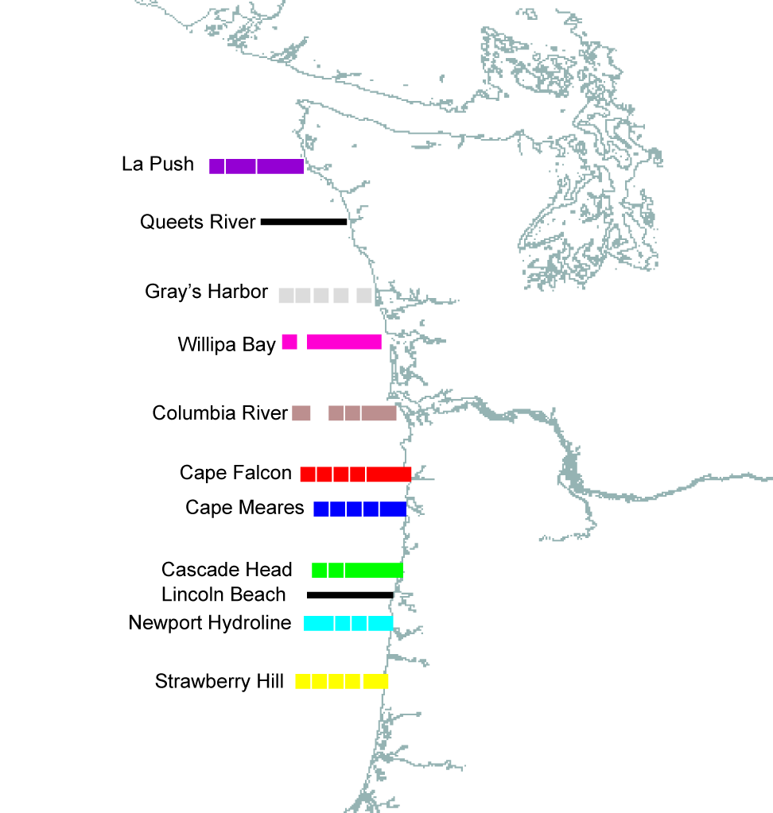

Station Table
Note that water sampling will occur at approximately 5 stations on each coastal transect line. Location of these stations will be determined in the weeks preceding the cruise.

Date | Station | Longitude |  | Latitude
14-Aug-07 | Newport, Oregon | 44 deg 37.50' |  | 124 deg 2.60'
14-Aug-07 | NH-10 | 44 deg 39.10' |  | 124 deg 17.70'
15-Aug-07 | Newport, Oregon | 44 deg 37.50' |  | 124 deg 2.60'
15-Aug-07 | SH-10 | 44 deg 15.10' |  | 124 deg 7.39'
15-Aug-07 | SH-15 | 44 deg 15.10' |  | 124 deg 7.64'
15-Aug-07 | SH-30 | 44 deg 15.10' |  | 124 deg 8.04'
15-Aug-07 | SH-40 | 44 deg 15.10' |  | 124 deg 9.00'
15-Aug-07 | SH-50 | 44 deg 15.10' |  | 124 deg 10.12'
15-Aug-07 | SH-70 | 44 deg 15.10' |  | 124 deg 15.13'
15-Aug-07 | SH-90 | 44 deg 15.10' |  | 124 deg 23.51'
15-Aug-07 | SH-100 | 44 deg 15.10' |  | 124 deg 27.70'
15-Aug-07 | SH-f | 44 deg 15.10' |  | 125 deg 9.52'
16-Aug-07 | LB-100 | 44 deg 51.50' |  | 124 deg 12.25'
16-Aug-07 | LB-90 | 44 deg 51.50' |  | 124 deg 10.87'
16-Aug-07 | LB-80 | 44 deg 51.50' |  | 124 deg 10.11'
16-Aug-07 | LB-70 | 44 deg 51.50' |  | 124 deg 9.27'
16-Aug-07 | LB-60 | 44 deg 51.50' |  | 124 deg 6.96'
16-Aug-07 | LB-70 | 44 deg 51.50' |  | 124 deg 9.27'
16-Aug-07 | LB-80 | 44 deg 51.50' |  | 124 deg 10.11'
16-Aug-07 | LB-90 | 44 deg 51.50' |  | 124 deg 10.87'
16-Aug-07 | NH-1 | 44 deg 39.10' |  | 124 deg 6.00'
16-Aug-07 | NH-3 | 44 deg 39.10' |  | 124 deg 7.80'
16-Aug-07 | NH-5 | 44 deg 39.10' |  | 124 deg 10.60'
16-Aug-07 | NH-10 | 44 deg 39.10' |  | 124 deg 17.70'
16-Aug-07 | NH-15 | 44 deg 39.10' |  | 124 deg 24.70'
16-Aug-07 | NH-20 | 44 deg 39.10' |  | 124 deg 31.70'
16-Aug-07 | NH-25 | 44 deg 39.10' |  | 124 deg 39.00'
16-Aug-07 | NH-35 | 44 deg 39.10' |  | 124 deg 53.00'
16-Aug-07 | NH-45 | 44 deg 39.10' |  | 125 deg 7.00'
16-Aug-07 | NH-55 | 44 deg 39.10' |  | 125 deg 22.00'
16-Aug-07 | CH-25 | 45 deg 3.00' |  | 124 deg 34.30'
16-Aug-07 | CH-20 | 45 deg 3.00' |  | 124 deg 27.50'
17-Aug-07 | CH-15 | 45 deg 3.00' |  | 124 deg 20.50'
17-Aug-07 | CH-10 | 45 deg 3.00' |  | 124 deg 14.00'
17-Aug-07 | CH-5 | 45 deg 3.00' |  | 124 deg 8.00'
17-Aug-07 | CH-2 | 45 deg 3.00' |  | 124 deg 4.50'
17-Aug-07 | CH-1 | 45 deg 3.00' |  | 124 deg 2.00'
17-Aug-07 | CM-1 | 45 deg 29.00' |  | 124 deg 0.40'
17-Aug-07 | CM-3 | 45 deg 29.00' |  | 124 deg 2.20'
17-Aug-07 | CM-5 | 45 deg 29.00' |  | 124 deg 5.50'
17-Aug-07 | CM-10 | 45 deg 29.00' |  | 124 deg 12.50'
17-Aug-07 | CM-15 | 45 deg 29.00' |  | 124 deg 19.60'
17-Aug-07 | CM-20 | 45 deg 29.00' |  | 124 deg 26.90'
17-Aug-07 | CM-25 | 45 deg 29.00' |  | 124 deg 33.60'
17-Aug-07 | CM-30 | 45 deg 29.00' |  | 124 deg 40.80'
17-Aug-07 | CM-a | 45 deg 29.00' |  | 124 deg 55.04'
17-Aug-07 | CM-b | 45 deg 29.00' |  | 125 deg 9.20'
17-Aug-07 | CF-30 | 45 deg 44.00' |  | 124 deg 39.00'
17-Aug-07 | CF-25 | 45 deg 44.00' |  | 124 deg 32.00'
18-Aug-07 | CF-20 | 45 deg 44.00' |  | 124 deg 25.00'
18-Aug-07 | CF-15 | 45 deg 44.00' |  | 124 deg 18.00'
18-Aug-07 | CF-10 | 45 deg 44.00' |  | 124 deg 11.10'
18-Aug-07 | CF-7 | 45 deg 44.00' |  | 124 deg 6.90'
18-Aug-07 | CF-3 | 45 deg 44.00' |  | 124 deg 1.50'
18-Aug-07 | CF-1 | 45 deg 44.00' |  | 123 deg 58.50'
18-Aug-07 | CR-4 | 46 deg 10.00' |  | 124 deg 4.60'
18-Aug-07 | CR-7 | 46 deg 10.00' |  | 124 deg 9.50'
18-Aug-07 | CR-10 | 46 deg 10.00' |  | 124 deg 13.10'
18-Aug-07 | CR-15 | 46 deg 10.00' |  | 124 deg 20.00'
18-Aug-07 | CR-20 | 46 deg 10.00' |  | 124 deg 27.10'
18-Aug-07 | CR-25 | 46 deg 10.00' |  | 124 deg 33.40'
18-Aug-07 | CR-30 | 46 deg 10.00' |  | 124 deg 40.20'
18-Aug-07 | CR-35 | 46 deg 10.00' |  | 124 deg 47.50'
18-Aug-07 | CR-40 | 46 deg 10.00' |  | 124 deg 54.60'
18-Aug-07 | CR-50 | 46 deg 10.00' |  | 125 deg 1.80'
18-Aug-07 | CR-50 | 46 deg 10.00' |  | 125 deg 1.80'
18-Aug-07 | CR-40 | 46 deg 10.00' |  | 124 deg 54.60'
18-Aug-07 | CR-35 | 46 deg 10.00' |  | 124 deg 47.50'
19-Aug-07 | CR-30 | 46 deg 10.00' |  | 124 deg 40.20'
19-Aug-07 | CR-25 | 46 deg 10.00' |  | 124 deg 33.40'
19-Aug-07 | CR-20 | 46 deg 10.00' |  | 124 deg 27.10'
19-Aug-07 | CR-15 | 46 deg 10.00' |  | 124 deg 20.00'
19-Aug-07 | CR-10 | 46 deg 10.00' |  | 124 deg 13.10'
19-Aug-07 | CR-7 | 46 deg 10.00' |  | 124 deg 9.50'
19-Aug-07 | CR-4 | 46 deg 10.00' |  | 124 deg 4.60'
19-Aug-07 | Astoria, Oregon | 46 deg 12.50' |  | 123 deg 46.00'
19-Aug-07 | QR-3 | 47 deg 32.00' |  | 124 deg 25.50'
19-Aug-07 | QR-6 | 47 deg 32.00' |  | 124 deg 30.00'
20-Aug-07 | QR-10 | 47 deg 32.00' |  | 124 deg 36.50'
20-Aug-07 | QR-14 | 47 deg 32.00' |  | 124 deg 42.00'
20-Aug-07 | QR-19 | 47 deg 32.00' |  | 124 deg 48.50'
20-Aug-07 | QR-24 | 47 deg 32.00' |  | 124 deg 56.00'
20-Aug-07 | QR-29 | 47 deg 32.00' |  | 125 deg 3.50'
20-Aug-07 | LP-52 | 47 deg 55.00' |  | 125 deg 55.70'
20-Aug-07 | LP-42 | 47 deg 55.00' |  | 125 deg 40.82'
20-Aug-07 | LP-32 | 47 deg 55.00' |  | 125 deg 25.94'
20-Aug-07 | LP-27 | 47 deg 55.00' |  | 125 deg 18.50'
20-Aug-07 | LP-22 | 47 deg 55.00' |  | 125 deg 11.50'
20-Aug-07 | LP-17 | 47 deg 55.00' |  | 125 deg 5.00'
20-Aug-07 | LP-12 | 47 deg 55.00' |  | 124 deg 57.50'
20-Aug-07 | LP-9 | 47 deg 55.00' |  | 124 deg 52.50'
20-Aug-07 | LP-6 | 47 deg 55.00' |  | 124 deg 47.50'
20-Aug-07 | LP-4 | 47 deg 55.00' |  | 124 deg 44.50'
21-Aug-07 | Columbia R. Plume
22-Aug-07 | Columbia R. Plume
23-Aug-07 | Columbia R. Plume
23-Aug-07 | Astoria, Oregon | 46 deg 12.50' |  | 123 deg 46.00'
24-Aug-07 | WB-5 | 46 deg 40.00' |  | 124 deg 11.00'
24-Aug-07 | WB-9 | 46 deg 40.00' |  | 124 deg 17.50'
24-Aug-07 | WB-14 | 46 deg 40.00' |  | 124 deg 24.00'
24-Aug-07 | WB-19 | 46 deg 40.00' |  | 124 deg 30.50'
24-Aug-07 | WB-23 | 46 deg 40.00' |  | 124 deg 36.50'
24-Aug-07 | WB-30 | 46 deg 40.00' |  | 124 deg 47.00'
24-Aug-07 | WB-40 | 46 deg 40.00' |  | 125 deg 1.50'
24-Aug-07 | WB-50 | 46 deg 40.00' |  | 125 deg 16.02'
24-Aug-07 | GH-36 | 47 deg 0.00' |  | 125 deg 3.70'
24-Aug-07 | GH-31 | 47 deg 0.00' |  | 124 deg 56.40'
24-Aug-07 | GH-26 | 47 deg 0.00' |  | 124 deg 48.80'
24-Aug-07 | GH-21 | 47 deg 0.00' |  | 124 deg 41.70'
24-Aug-07 | GH-16 | 47 deg 0.00' |  | 124 deg 33.50'
24-Aug-07 | GH-10 | 47 deg 0.00' |  | 124 deg 25.00'
24-Aug-07 | GH-6 | 47 deg 0.00' |  | 124 deg 19.20'
24-Aug-07 | GH-3 | 47 deg 0.00' |  | 124 deg 14.80'
25-Aug-07 | To be decided
26-Aug-07 | Columbia River estuary
27-Aug-07 | Columbia River estuary
28-Aug-07 | Columbia River estuary
29-Aug-07 | Columbia R. Plume
30-Aug-07 | Columbia R. Plume
31-Aug-07 | Newport, Oregon | 44 deg 37.50' | 124 deg 2.60'
Summary of Operations Diagram

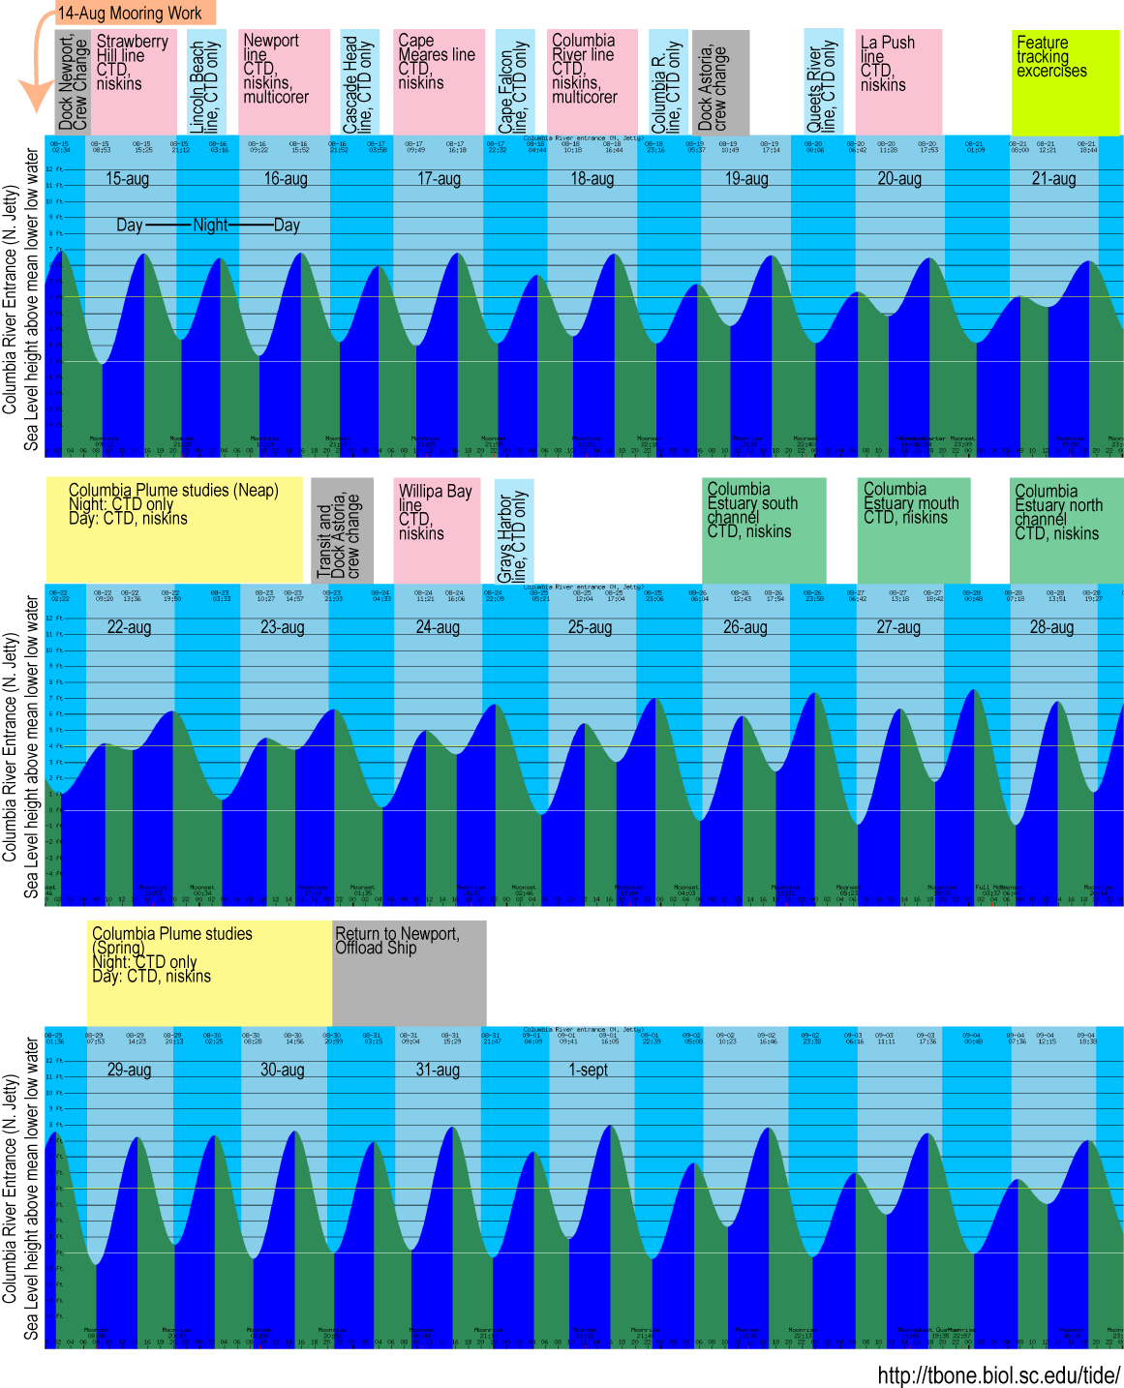

Contact Information

Equipment List R/V Wecoma
- Standard Ship’s Outfit
  - SeaBird CTD system with transmissometer, fluorometer, PAR, O2, altimeter. Anticipated 250 casts
  - SBE Carousel samplers - 12 bottles. 10L bottles
  - RDInstruments shipboard Doppler current profilers; Frequency 75/300 kHz. Dual system required.
  - DAS shipboard data logging/display system
  - Shipboard networking services (to be arranged)
  - Winch slip rings - 4-conductor – for CTD
  - Dry Lab tables and cabinets in various heights and sizes (To be arranged)
  - Portable refrigerator (15 cu. ft.)
  - Portable chest freezers (2 @ 7 ft³)
- Transient Equipment
  - Low Temperature freezer (1 available) -85C, 5 cu. ft.
- Ship’s Deck Equipment
  - Hydro Winch: 0.322” 3-conductor EM for CTD, 1000m max depth.
  - Trawl Winch for mooring operations; trawl wire; disable level wind to be able to pass hardware and wrap mooring wire on drum.
  - Coring Winch: 9/16” wire rope for deploying multicorer. 1000m max depth
  - Hydro A-Frame for deploying CTD and Niskin Bottles
  - Capstan required for mooring work
  - Stern A-frame for deploying multicorer and mooring operations
  - Portable Air tugger/air winches – 2 requested – for multicorer work and mooring operations
- Vans
  - Storage Van
  - New Radiation Laboratory Van

Equipment List for Science Party
- Sensors
  - OBS - to be integrated into CTD system
  - ISUS sensor for measuring NO₃
- Incubator for use in New Radiation Laboratory Van

On-loading and Off-loading details

Ship loading will begin in the morning on Aug 13. Several containers of equipment and supplies will arrive by mail the preceding week. Scientific crew will arrive throughout the day to load the ship and set up the equipment. Assistance with loading heavy equipment (via crane) is requested between the hours of XXX and XXX.

Off-loading will begin on the morning of Sept 31. We hope to arrive in Newport early that morning, so offloading can commence at around daybreak. Assistance with loading heavy equipment (via crane) is requested that morning.

Deck and Lab arrangement
Berthing Charts

